**顾慈勇 讲师**

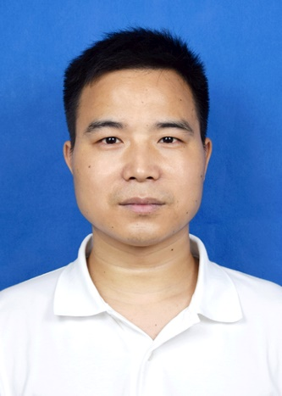

**一、个人简介**

顾慈勇，男，中共党员，博士，主要研究方向为表面等离激元纳米光子学和表面增强拉曼散射（SERS）的理论研究、光纤SERS传感技术、SERS生物传感器的制备及在食品安全领域的分析测试应用。2023年获南京航空航天大学博士学位。近来以第一作者或通信作者发表学术论文6篇，其中SCI论文5篇。

联系方式：桂林市建干路12号桂林理工大学物理与电子信息工程学院（邮编：541004）

电子邮址：[guciyong@glut.edu.cn](mailto:guciyong@glut.edu.cn)

**二、代表性的成果**

[1] **Ciyong Gu**, Delong Meng, Xiaolei Yu et al. Highly Sensitive and Flexible GFF/Au/AgNPs SERS Substrate and Its Application for Rapid Hazardous Residues Detection on Food. Plasmonics, 2023, 18(4), 1541-1552.

[2] **Ciyong Gu**, Delong Meng, Zhimin Zhao et al. Design and Optimization of Tapered Optical Fiber Probes for SERS Utilizing FDTD Method. Plasmonics, 2022, 17(5), 2205-2211.

[3] **Ciyong Gu**, Zhimin Zhao, Pengcheng Shi. Development of a Monolayer AuNPs Decorated on Optical Fiber Facet for SERS Analysis. Applied Optics, 2020, 60(3):792-798.

[4] **Ciyong Gu**, Shiqing Man, Zhimin Zhao et al. Preparation of Silicon Surface Pyramid Arrays and Modification of Thin Gold Film for Surface-enhanced Raman Scattering. IOP Conference Series: Materials Science and Engineering, 2018, 394(2).

[5] Delong, Meng, **Ciyong Gu\***, Lin Li et al. Application of Ultraviolet-visible Spectroscopy Coupled with Support Vector Regression for the Quantitative Detection of Thiamethoxam in Tea, Applied Optics, 2022, 61(21):6186-6192.